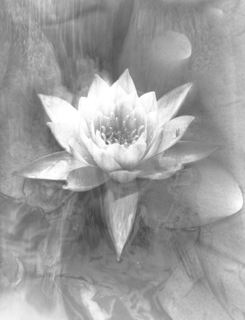
Registration Form (Confidential)
Please fill out and email to ingrid@homeopathe.ca before your consultation. Do not print if possible.
If you are filling this out for your child, make sure he/she participates in answering the questions, if old enough. If he/she was vaccinated, please bring or email copies of vaccination card pages.

Name and Family name:

Name of parents if under 18 :

Occupation :

Birth date : Age :

Address :

City :

Zip/Area Code :

Telephone (iPhone FaceTime ?) :

Email :

SKYPE ID :

Please add me to your contact list : Oui Non

If you wish to receive health and homeopathy tips and updates, invitations to conferences and events, you may subscribe to my contact list on my website, at the bottom of my Home page and on my FaceBook page Ingrid Homeopathe.

Recommended by :

Reasons for consultations Please try to remember as precisely as possible when your symptoms first started. VERY IMPORTANT !!
Health issue ? Since ? Causes ?
1.
2.
3.
4.

What medication are you taking ?
Medication Since ? Side effects
1.

2.

3.

Are you under a treatment of diet ?
Treatment of Diet ? Since ? Results
1.

2.

3.

Vaccines ? For vaccinated children, please show vaccination card.
Vaccines Date Side Effects
1.

2.

3.

Surgeries ? When ? Complications ?
1.

2.

Major Injuries ? When ? Long term complications?

1.

2.

3.

***This section is very important. Write the year and month if possible. Do not just check with an X. If applicable, call your pharmacist to trace the year and month you started a medication. This might help you remember when your symptoms started.
Write the year, month if possible, of symptoms onset. VERY IMPORTANT !!

Abces | Fever | Measles | STD
Abortion/miscarriage | Flu | Ménopause | Syphilis
Alcoholism | Gallbladder stones | Mononucleosis | Throat infection/Tonsilitis
Allergies | Goitre | Mumps | Typhoid
Anemia | Gonorrhea | Chickenpox | Tuberculosis
Arthritis | Gout | Otitis | Vaginitis/ Yeast infection
Asthma | Heart Disease | Parasites | Warts/Condyloma
Boulimia | Hepatitis | Pleuresy | Zona
Cancer | Herpes (genital) | Pneumonia | Others ?
Cough/whooping cough | Herpes (fever blister) | Prostatite
Depression | Infarctus | Rhumatism/articular
Diabetes | Infections (various) | Rubella
Emphysema | Kidney/Bladder | Scarlet Fever
Endometriosis | Leukaemia | Sinusitis
Epilepsie | Malaria | Skin Disease

Have you ever taken antibiotics ?
For what illness and when ?
Have you gained or lost much weight ?
Yes No How many pounds in loss or gain ?

Do you exercise ?
Exercises : Frequency :
1.
2.
3.

What is your daily or weekly intake of
Tobacco : Alcohol : Coffee :
Tea : Drugs :

How many
Pregnancies : Children : Abortions :

What affected your family members ?
Alcoholism | Depression | Heart Disease | Syphilis
Allergies | Diabetis | Skin Disease | Mental illness
Arthritis | Epilepsy | Paralysis | Tuberculosis
Asthma | Gonorrhea | Pneumonia | Others ?
Cancer | Gout

Family Health History:

Family Member | Age if alive | Age when passed away | Main illnesses
Mother
Father
Brothers/Sisters
Grand-parents Mater.
Grand-parents Pater.
Oncles Aunts Mater.
Oncles Aunts Pater.

When was your last complete medical examination ?

Are you under the care of a medical doctor ?

Name ? For what illness ?

Treatments Results?
1.

2.

Were you ever treated by a homeopath ?
Name of Homeopath ? For what illness or symptoms ? Treatment and results ?

1.

2.

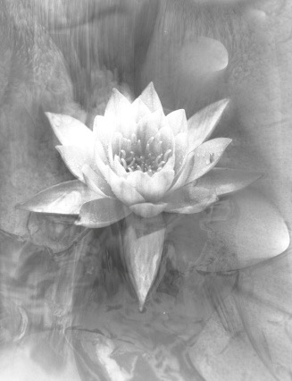
2nd part of registration form

We will look in more details at these questions during the consultation.

IMPORTANT !! Please try your very best to remember as precisely as possible WHEN in your life your symptoms, for each illness, first started. YEAR, MONTH ? Answer spontaneously to the

About your symptoms
When did they first started ?
For each different illness you suffer from today.

How did they first appear ? After what event, what medication ? What do you think triggered the onset ? Stress ? Medication ? Some event ?

Please describe who the symptoms first started ? What did it feel like or look like ? Sensations ? Pain ? Always around the same time ? Same side of body ?

What makes your symptoms worse or better ?
What do you do to soothe the pain ? What can trigger the symptoms ?

Have you noticed a singular state the symptoms will put you in ? Mood ?

Other details about your symptoms ? Any changes in your appetite, your food cravings or aversion since ? Are you more sensitive to certain weather ? Any changes in your sleep since the onset of symptoms ?

Food and Appetite
What are you INTENSE food cravings ?
Healthy or not. What is your very favourite food ? How intense is your craving ? Every day ? You would walk in a snow storm to purchase that food?

Anything you FREQUENTLY want to add to your food ?
Hot spices, vinegar, lemon, salt, pepper, sugar, ketchup ?

Any Food AVERSIONS ? Major dislikes, you just could not have.

Any Food allergies ? You may enjoy the taste but it does not agree with you ? Digestive reaction, fatigue or else ?

How is your appetite ? Are you hungry or not hungry at all at specific hours? No breakfast ? Late second dinner ?

Any preference to food temperature ?

Drinks and Thirst
How is your thirst ? Day, night ?

Any beverage preferences or aversions ?

Any temperature preferences or aversions ? Warm, icy cold, room temperature

Digestion
How is your digestion ?

How are your stools and urine ?
Pain, frequency ?

Climat
What climate are you sensitive to, if any ? What temperature do you strongly enjoy or dislike ? Seasons, thunder, rain, heat, cold, damp ?

Body Temperature
Are you chilly, or more on the hot side ? Excessive sweat or chilliness ?
Which part of body and when ? Day, night ?

Since when ?

Menstrual Cycle Please mention if you are consulting during your menstruation. You may need to take the remedy later in your cycle.
Age of first menstruation ?

How is your cycle ? Pain, regularity ?

PMS ?What are you sensitive to during PMS ?

Sleep
How is your sleep ?

How easy is it for you to fall asleep ? Around what time ?

How is your energy upon waking ?

What do you need to sleep well ?
Windows opened even in winter, cold or warmth, covered or uncovered, a fan, noise or complete silence, a specific position ? What is recurring ?

Any favourite position ?

Sleep walking, talking ?

Anything else about your sleep ?

Dreams
What are the recurring dreams, or the one or two striking dreams you remember ? Do you always remember of forget your dreams ?

Have you noticed a higher or lower energy cycle during the day ?

Emotions
What are you most sensitive to ? What upsets you, makes you cry, makes you angry, very very happy ? What type of event can turn you upside down ? What are the recurring and intense emotions in your life, in a day, in a week?

What are the major events of your life ?
Happy of not.

What are you passionate about ? What are you most interested in ?

What scares your, causes great sudden fear ? Irrational fear even, that may not be related to a life event ?

What are the movies, T.V. shows, songs, plays, books that have made you cry or feel something so very intense. Anytime in your life. Please name as many as you can and remember the specific scene.

If you need to cancel an appointment you have with me, you are asked to give a 24 hour notice during week days and working hours so that your place can be offered to someone else.
Without a 24 hour notice, you will be asked to pay for the consultation.

Ingrid Schutt

* I have read the cancellation conditions

Signature: ______________________________________

** What you need to know about the consultation. IMPORTANT !!!

Here are some important points about the consultation and the treatment.

— Ladies : Please mention if you are consultation during your period for you may need to take the remedy later in your cycle.

*** VERY IMPORTANT !!
I can never say this enough. As long as you are not fully recovered, you must avoid all contact (food, tea, toothpaste, candy, gum, lotion, essential oils…) with eucalyptus, peppermint, camphor products. Buy a NO MINT toothpaste. Natural Health Food stores sell excellent anise or cinnamon toothpastes. If you go to a spa and smell the eucalyptus essential oils, tell me so you can take another dose in case the healing effect of your remedy stops. These three products are strong ANTIDOTES that can totally kill the effect of your remedy, as long as the remedy is still taking its course and as long as your body has not fully and strongly recovered. It may be a month or two after your symptoms have fully disappeared.
I can not repeat this enough. Many patients think the remedy doesn’t do anything while they actually eat peppermint gum every day and destroy their remedy. So NO MINT, NO CAMPHOR, NO EUCALYPTUS for at least a month of two after your symptoms have gone.

—The goal of the consultation is to determine which remedy is best suited for you, to balance your vital energy and strengthen your body’s defence mechanism.

The homeopathic consultation is a team work and your answers help me find the best remedy for you.
Thank you for taking the time to answer the questions.

Looking forward to meeting you in a consultation.

Ingrid Schutt

